**YEAR 12 CHEMISTRY – ATCHE**

**TEST 1**

**Reaction Rates and Equilibrium 2021**

**15 MULTIPLE CHOICE QUESTIONS**

**/65**

**Recommended time: 55 Minutes**

Name: ___________________________________________

Teacher: ___________________________________________

This test is in two parts.

**Section 1:** Multiple choice style test consisting of (15) questions. **(15 Marks )**

Each question is worth 1 mark.

Write your answers in the table provided.

Attempt **ALL** Questions

**Section 2:** Short and/or Extended Answer questions **(50 Marks)**

Write all answers in the spaces provided.

The marks allocated to each question are shown for each question

Note that ALL questions DO NOT carry an equal number of marks.

Read the questions carefully and keep an eye on the allocated time

Attempt **ALL** Questions

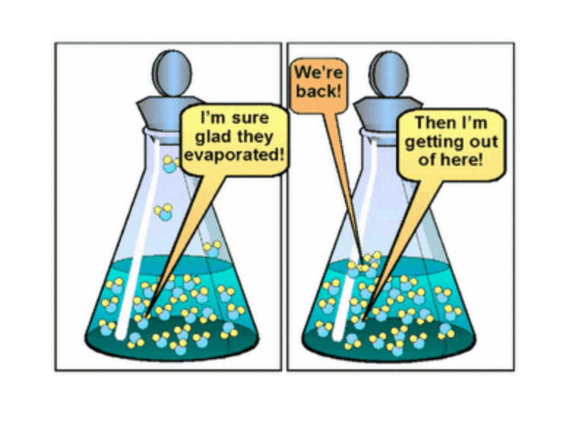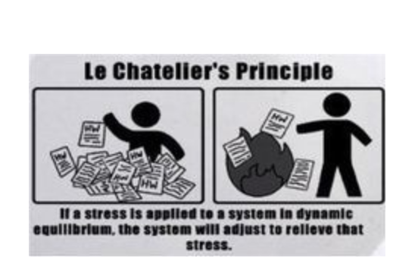

**Section 1**: 15 multiple choice questions. Answer All the questions on a separate answer by clearly writing the answer neatly onto the table provided. Each correct answer scores 1 mark up to a maximum of **15 marks.**

Q1. The reaction of coal with steam in a vessel at constant volume produces a mixture

of hydrogen and carbon monoxide gases.

C (graphite) + H2O (g)  **⮀** H2 (g) + CO (g) ΔH = 131 kJ mol – 1

Which one of the following would slow down the rate of reaction?

(A) Decreasing the pressure of the steam.

(B) Grinding up the coal.

(C) Injecting CO gas into the reaction vessel.

(D) Raising the temperature of the steam.

Q2. Which of the following best explains the way in which a catalyst increases the rate of a reaction?

(A) A catalyst increases the rate of the forward reaction but not the reverse

reaction: hence the overall rate is increased.

(B) A catalyst provides additional energy to the particles: hence a greater fraction

of collisions is effective.

(C) A catalyst provides an alternative reaction pathway with a lower activation energy:

hence a greater fraction of collisions is effective.

(D) A catalyst provides an alternative reaction pathway with a lower heat of reaction:

hence less energy is needed for the particles to react.

Q3. Gaseous hydrogen gas and oxygen gas are reacted to form steam as shown.

2H2 (g) + O2 (g)  2H2O (g)

The value of equilibrium constant, K, will depend on

(A) the initial concentration of H2

(B) the initial concentration of H2O

(C) the temperature of the system

(D) the volume of the reaction vessel

Q4. The equilibrium constant, K, for a gaseous phase reaction that occurs is shown.

[ CO2] [ CF4]

K = __________

[COF2] 2

The chemical equation for this equilibrium is :

(A) CO2 (g) + CF4 (g) **⮀** COF2(g)

(B) CO2 (g) + CF4 (g) **⮀** 2COF2(g)

(C) CO2F(g) **⮀** CO2 (g) + CF4 (g)

(D) 2COF2(g) **⮀** CO2 (g) + CF4 (g)

Q5. Hydrogen gas, H2(g), is produced industrially from methane, CH4(g). The

equation for the reaction is:

2H2O(g) + CH4(g) ⇌ CO2 (g) + 4H2(g)

If an inert gas argon is added to the equilibrium system at constant temperature and constant volume, the concentration of hydrogen will:

(A) increase

(B) decrease

(C) not change

(D) decrease and then increase

The next **two** questions Q6 and Q7 are to be answered below:

Q6. The following graph represents the enthalpy (H) changes that occur in the

reaction:

Reactants 🠪 Products

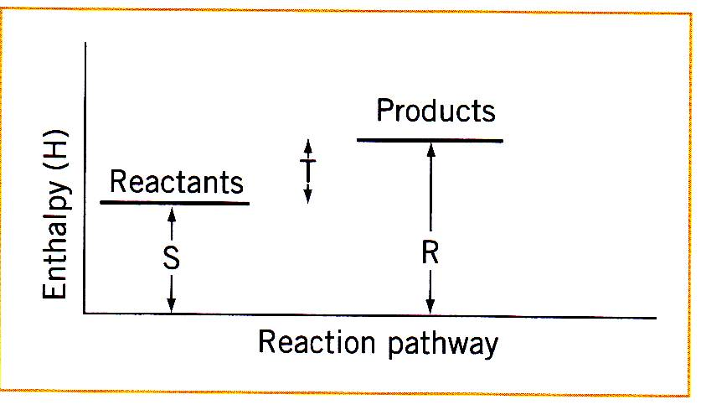

T

Which of the following represents the ΔH of the reaction?

(A) S

(B) T

(C) R

(D) S + T

Q7. Which one of the following is correct for the reaction shown in Question 6 above?

|  |  |  |  |
| --- | --- | --- | --- |
|  | Type of Reaction | Sign of ΔH | Change in the temperature of the surroundings due to the reaction |
| (a) | Endothermic | Positive | decrease in temperature |
| (b) | Endothermic | Negative | increase in temperature |
| (c) | Exothermic | Negative | increase in temperature |
| (d) | Exothermic | Positive | decrease in temperature |

Q8. Which one of the following statements concerning the equilibrium reaction below is INCORRECT ?

**CO2 (g) 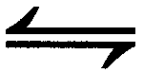 CO2 (aq) ∆H = -156 kJ**

1. the equilibrium constant (K) for the dissolving of CO2(g) in water is

Increased by higher pressure

1. carbon dioxide gas is less soluble in water as temperature increases
2. injecting more CO2(g) will cause an increase in the concentration of

dissolved CO2 (aq)

1. the equilibrium constant (K) for the reverse reaction is unchanged

unless a change in temperature occur

Q9. The following system is at equilibrium

SO2(g) + NO2(g)  **⇌** SO3(g) + NO(g) + 42 kJ

Which of the following changes will be certain to increase the equilibrium partial pressure of NO(g)

1. Increasing the temperature
2. Removing heat from the system
3. Adding more SO3(g)
4. Adding a catalyst
5. Increasing the concentration of NO2(g)
6. Increasing the pressure
7. Decreasing the pressure

(A) (ii) and (v)

(B) (ii), (iii) and (v)

(C) (ii), (iv), (v) and (vi)

(D) (i), (iv), (v) and (vii)

Q10. A mixture of hydrogen gas and purple iodine vapour is sealed in a glass tube

where it undergoes a reaction to form colourless hydrogen iodide gas. Which of

the following could be used as a visible sign that equilibrium has been achieved?

**H2 (g) + I2 (g)** **⮀ 2HI (g)**

(A) Constant pressure.

(B) Constant colour.

(C) Constant mass.

(D) Constant volume.

The next **two** question 11 and 12 relate to realate to the following . The equilibrium between nitrogen dioxide, NO2(g), and dinitrogen tetroxide, N2O4, form as represented by the following equation.

**2 NO2 (g)  N2O4 (g) ∆H = - 57.2 kJ/mole**

brown colourless

A change is made at time (t1) to an equilibrium mixture of NO2 and N2O4

which achieved a new equilibrium at time (t2). A graph showing the rate of

forward reaction is shown below.

rate of

forward

reaction

T1 T2

Time

Q11. Which one of the following describes the change that was made to the initial

equilibrium system and the colour change that occurred between (t1) and (t2) ?

(A) The temperature was increased and the colour lightened

(B) The temperature was increased and the colour darkened

(C) The temperature was decreased and the colour lightened

(D) The temperature was decreased and the colour darkened

Q12. Which of the following changes would increase the **rate** at which the

equilibrium is reached, without affecting the position of equilibrium?

(A) increase pressure

(B) increase temperature

(C) decrease temperature

(D) Adding a catalyst

The diagram below shows a Maxwell- Boltzmann distribution of particle energies, including the activation energy (Ea) for a reaction.

Number of particles

With energy, E

Ea

Energy (E)

Q13. An increase in temperature will:

(A) Increase the area under the curve

(B) Move the peak of the curve to the right

(C) Raise the height of the peak

(D) Move the position of the activation energy, Ea, to the left

Q14. Which of the following does not change the **rate** of collisions between particles in a reaction?

(A) Addition of a catalyst.

(B) Increase in surface area.

(C) Increase in temperature.

(D) Decrease in the reaction volume

Q15. The Haber process involves the following equilibrium reaction:

**N2(g) + 3H2(g)  2NH3 (g)**

A number of closed reaction vessels were set up containing the gases as shown in the table below.

|  |  |
| --- | --- |
| **Reaction vessel** | **Gases initially present** |
| (i) | nitrogen, hydrogen |
| (ii) | nitrogen |
| (iii) | ammonia |
| (iv) | hydrogen, ammonia |

In which of the above closed reaction vessels would equilibrium be established after a period of time?

(A) i only

(B) ii and iii only

(C) i, iii, and iv only

(D) ii, iii, and iv only

**END OF MULTIPLE CHOICE QUESTIONS**

**YEAR 12 CHEMISTRY - ATCHE**

**TEST 1**

**Reaction Rates and Equilibrium 2021**

**STUDENT ANSWER SHEET**

**/65**

**-**

**Recommended time: 55 Minutes**

Name: ___________________________________________

Teacher: ___________________________________________

**Section 1: 15 Multiple choice questions. Answer All the questions in the table below by writing in the correct letter neatly. Each correct answer scores 1 mark. (15 marks)**

|  |  |  |  |  |  |  |  |  |  |
| --- | --- | --- | --- | --- | --- | --- | --- | --- | --- |
| **Q1** | **Q2** | **Q3** | **Q4** | **Q5** | **Q6** | **Q7** | **Q8** | **Q9** | **Q10** |
|  |  |  |  |  |  |  |  |  |  |

|  |  |  |  |  |
| --- | --- | --- | --- | --- |
| **Q11** | **Q12** | **Q13** | **Q14** | **Q15** |
|  |  |  |  |  |



**PART B – SHORT ANSWER & WRITTEN QUESTIONS (25 marks)**

Answer **ALL** the questions in the spaces provided below and read the questions carefully. Marks allocated for each question is shown next to it. Note that not all questions carry equal number of marks.

Q16. **(11marks)**

As a first step in the manufacture of nitric acid it has been suggested that nitrogen monoxide gas , NO, can be formed from nitrogen gas and oxygen gas in a revsible reaction.

(a) Write a balanced equation, including states of matter, for the reaction and deduce an expression for the equilibrium constant (K)

Equation: ___________________________________________________ (1 mark)

K = _____________________

(1 mark)

(b) The sketch graph below shows how the K value for the reaction changes with

temperature

K

Temperature

(c) Use the graph above to deduce whether the reaction is endothermic or

exothermic (1 mark)

___________________________________________________________________

Explain your answer using Le Chatelier’s Principle (2 marks)

___________________________________________________________________

___________________________________________________________________

___________________________________________________________________

16. (d) The value of K for this reaction is 1.00 x 10-5  at 1500 kelvin . Explain the significance of this value for an industrial chemist interested in producing nitrogen monoxide gas by the direct combination of the starting elements. (2 marks)

___________________________________________________________________

___________________________________________________________________

___________________________________________________________________

___________________________________________________________________

16 (e) When cooled, nitrogen monoxide reacts with oxygen gas to form gaseous nitrogen dioxide gas.

(i) Write a balanced chemical equation for this reaction. (1 mark)

___________________________________________________________________

(ii) State how an increase in pressure would change the position of the equilibrium and the change the value of the equilibrium constant (K).

Change in equilibrium position.:____________________________________________________(1 mark)

__________________________________________________________________

Change in the equilibrium constant: ( 2 marks)

___________________________________________________________________

___________________________________________________________________

­­­­­­­­­___________________________________________________________________

___________________________________________________________________

Q17. **(8 marks)**

Calcium hydroxide is slightly soluble in water. The equilibrium established when solid Ca(OH)2 is in contact with saturated solution is represented below:

Ca(OH)2 (s) ⮀ Ca 2+ (aq) + 2OH – (aq)

An equilibrium mixture of solid calcium hydroxide and its saturated solution is prepared. Four test tubes are set up, each containing some of the equilibrium mixture – a little white solid under a colourless solution. Each of the tubes is treated as described below. In each case state how the equilibrium will shift, and what will be observed.

|  |  |  |
| --- | --- | --- |
| What is done | How the equilibrium shifts. Write ‘⭢’, ‘⭠’, or ‘no change’ | What is observed. Give the complete observations. |
| A little concentrated hydrochloric acid is added  to the first tube |  |  |
| A little concentrated  (3 mol L – 1) calcium chloride is added to the second tube |  |  |
| A little solid calcium hydroxide is added to the third tube and the mixture shaken |  |  |
| A little solid sodium chloride is added to the fourth tube and the mixture shaken |  |  |

**Q18 (11 MARKS)**

Space X is an American company that wants to send humans to Mars to explore the planet and establish a colony. One big challenge of this mission is to find a reliable fuel source away from Earth.

The company plans to solve this problem by using the Sabatier reaction. The equation for the reaction is:

CO2 (g) + 4H2(g) **⇌** CH4 (g) + 2H2O (g) ∆H = -165 kJ/mole

The resulting methane gas could be used as rocket fuel. Tne yield in the Sabatier reaction.

|  |  |
| --- | --- |
| **Imposed Change** | effect on methane **yield** (circle your answer) |
| (i) a suitable catalyst is added | increase decrease no effect |
| (ii) the volume of the reaction vessel is increased | increase decrease no effect |
| (iii) the temperature is increased | increase decrease no effect |
| (iv) methane is removed as soon as it is formed using a special valve | increase decrease no effect |
| (v) the partial pressure of carbon dioxide is decreased | increase decrease no effect |

(5 marks)

(a) Graphs can be drawn to show the effects of imposed changes on equilibrium systems. The graph below shows the effects of some changes that might be made to the reacting system in a flexible vessel.

CO2 (g) + 4H2(g) **⇌** CH4 (g) + 2H2O (g) ∆H = -165 kJ/mole

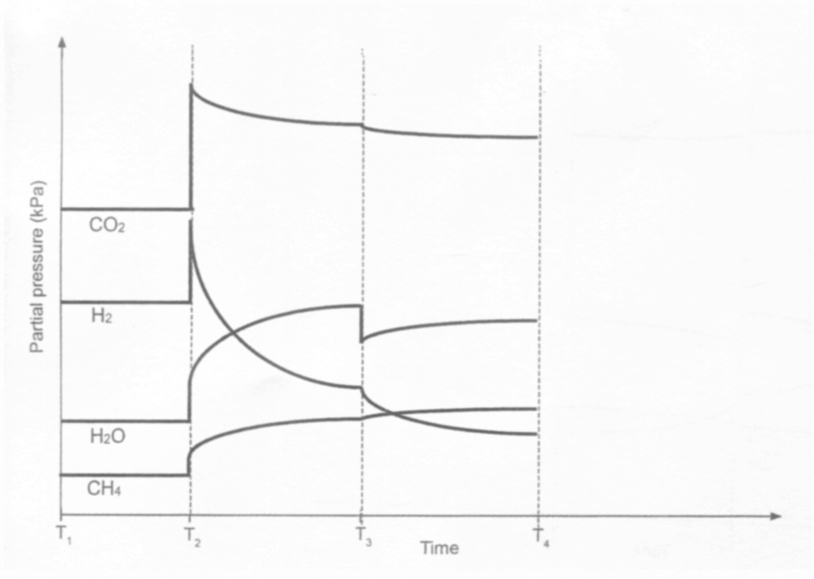

(b) By referencing the above graph, answer the following questions.What happened at T1 ? (1 mark)

___________________________________________________________________________

(c) Identify the imposed change at each time in the table below. (2 marks)

|  |  |
| --- | --- |
| **Time** | **Change imposed on the system** |
| T2 |  |
| T3 |  |

(d) The temperature of the reaction vessel was decreased at T4. Sketch,neatly, on

the graph above to show how this affected the partial pressure of all species present.

Include any changes to scale and continue until a new equilibrium is established. (3 marks)

**Q19 (14 MARKS)**

The two different coloured complex ions, [Co(H2O6]2+(aq) and [CoCl4]2- , exist together in equilibrium in solution in the presence of chloride ions. The equation is as shown below:

[Co(H2O)6]2+ (aq) + 4Cl- (aq)⇌ [CoCl4(aq) ]2- + 6 H2O(l)

Pink blue

An experiment was conducted to investigate the effects of equilibrium position by imposing a series of changes on the system. The shift in equilibrium position can be indicated by any colour change of the solution.

**COLOUR chart**

|  |  |
| --- | --- |
| **Species** | **colour** |
| [Co(H2O)6]2+ (aq) | Pink |
| [CoCl4(aq) ]2- | Blue |
| Initial equilibrium mixture | Purple |

After a 3.00 mL sample of the initial equilibrium was placed in each of these test tubes, changes to each system were made by adding a different substance, as indicated in the table below.

|  |  |
| --- | --- |
| Test tube | Substance added to the test tube |
| 1. | 1 – 2 drops of distilled water |
| 2. | 1 - 2 – 30 drops of concentrated 10 mol/L hydrochloric acid |
| 3. | 1 - 2drops of 0.250 mol/L AgNO3(aq) solution |

19 (a) complete the table below by predicting the:

* Change in concentration, if any, of each of the ions in solution compared to the initial solution, after a new equilibrium position is reached.
* Colour change, if any, that takes place from the initial purple- coloured solution

|  |  |  |
| --- | --- | --- |
| Addition to the test tube | change in concentration from initial concentration to final equilibrium.  **(increase, decrease, unchanged**) | Colour favoured  **(pink, blue or unchanged)** |
|  | [Co(H2O)6]2+ [ Cl-] [CoCl4 ]2- |  |
| 1. add water H2O (l) | . |  |
| 2. add  HCl (aq) |  |  |
| 3. add AgNO3 (aq) |  |  |



(6 marks)

19 (b) Other than a colour change, what else should be observed in test tube 3?

(1 mark)

___________________________________________________________________

19 (c) Using Collision Theory, explain your predicted observations when hydrochloric acid is added to test tube 2. (4 marks)

___________________________________________________________________

___________________________________________________________________

___________________________________________________________________

___________________________________________________________________

___________________________________________________________________

___________________________________________________________________

___________________________________________________________________

___________________________________________________________________

Another experiment was conducted to investigate the effect that changing the temperature had on the equilibrium mixture. When 3.00 mL of original equilibrium mixture was placed in a test tube and then in an ice bath bath, the solution became pink.

19 (d) Determine whether the forward reaction, as shown by the equation below, is endothermic or endothermic. Use Le Chatelier’s Principle to justify your answer.

(3 marks)

[Co(H2O)6]2+ (aq) + 4Cl- (aq)⇌ [CoCl4(aq) ]2- + 6 H2O(l)

Pink blue

___________________________________________________________________

___________________________________________________________________

___________________________________________________________________

___________________________________________________________________

___________________________________________________________________

__________________________________________________________________

**Q20 (6 MARKS)**

Ocean acidification results from carbon dioxde dissolving in water and an equilibrium being established between water and carbon dioxide to carbonic acid, H2CO3

(a) write a balanced equation for this equilibrium (2 marks)

___________________________________________________________________

(b) The formation of carbonic acid leads to an increase in hydronium ion (H3O+) concentration in water. Show the equilibrium that results in the formation of hydronium ions when carbonic acid reacts with water. (1 mark)

______________________________________________________________

(c) State one problem ocean acidification is causing for marine invertebrates (organisms). Explain how this problem arises and support your answer with an appropriate balanced equation. (3 marks)

___________________________________________________________________

___________________________________________________________________

___________________________________________________________________

___________________________________________________________________

­­­­­­­­­­­­­­­­­­­­­­­­­­­­

___________________________________________________________________

___________________________________________________________________

­­­­­­­­­­­­­­­­­­­­­­­­­­­­

___________________________________________________________________

___________________________________________________________________

___________________________________________________________________

___________________________________________________________________

**END OF EQUILIBRIA TEST 1 2021. GO – BACK & RE-CHECK YOUR ANSWERS**

**Extra continuation sheets if required for written answers.**

**__________________________________________________________________________**

**___________________________________________________________________________**

**___________________________________________________________________________**

**___________________________________________________________________________**

**__________________________________________________________________________**

**___________________________________________________________________________**

**___________________________________________________________________________**

**___________________________________________________________________________**

**END OF YEAR12 CHEMISTRY TEST 1 EQUILIBRIUM & RATES 2021**